|  |
| --- |
| Close-up image showing the leaf-sides of two oversized books side-by-side on a bookshelf, with additional books in soft focus background |
| Digital Simulation Using Verilog in Modelsim  Experiment 9 |
| |  |  |  | | --- | --- | --- | | BIMAL PARAJULI (20BDS0405) | 7/18/21 | CSE – 1003 (LAB) | |

Verilog Simulation of a basic Inverter:

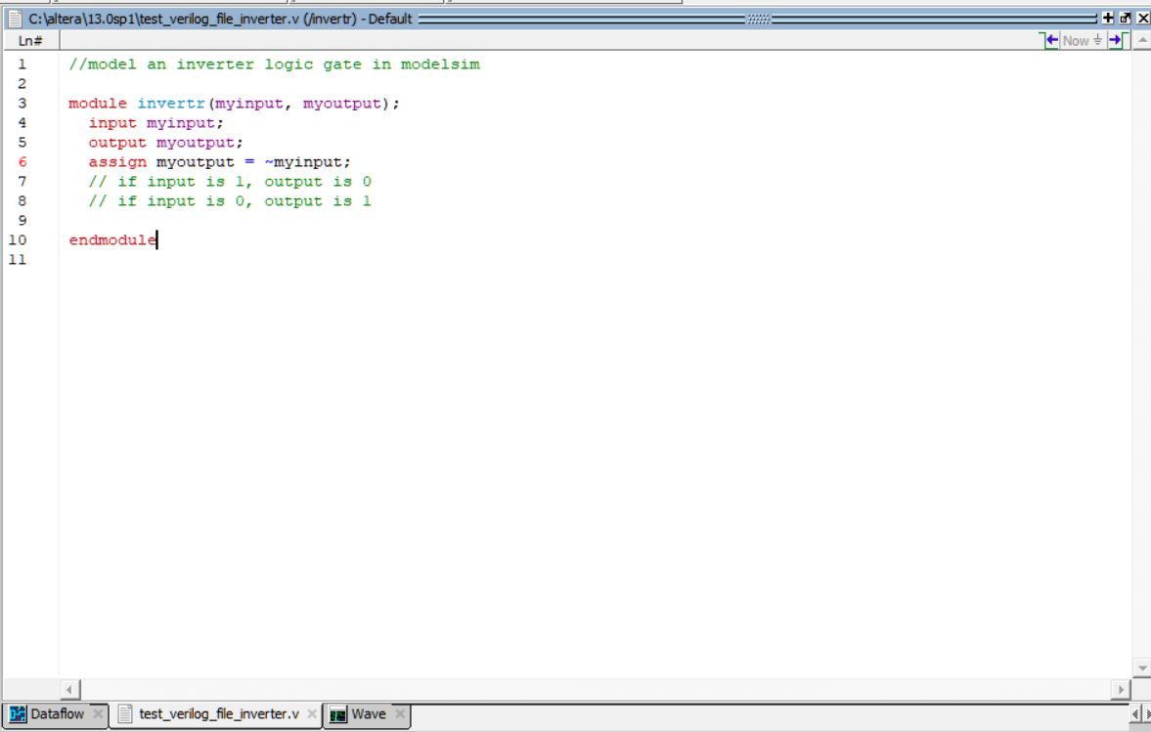

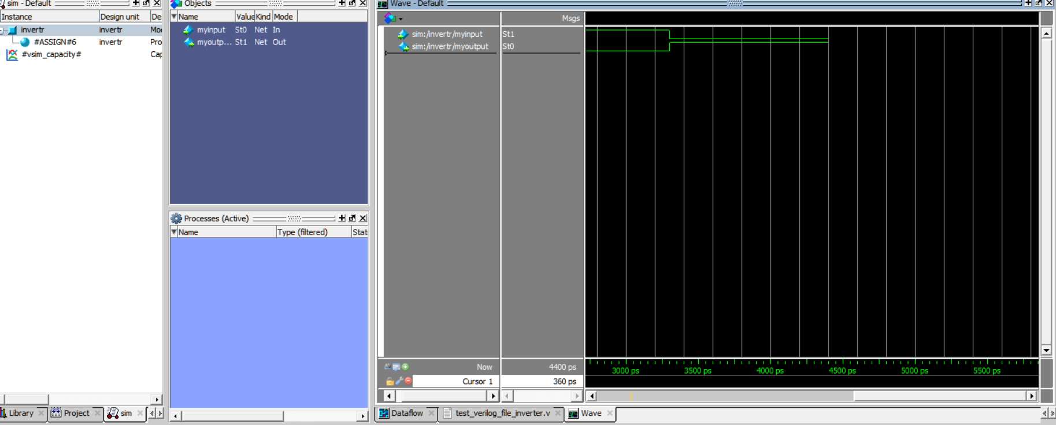

Verilog Simulation of a half Adder: 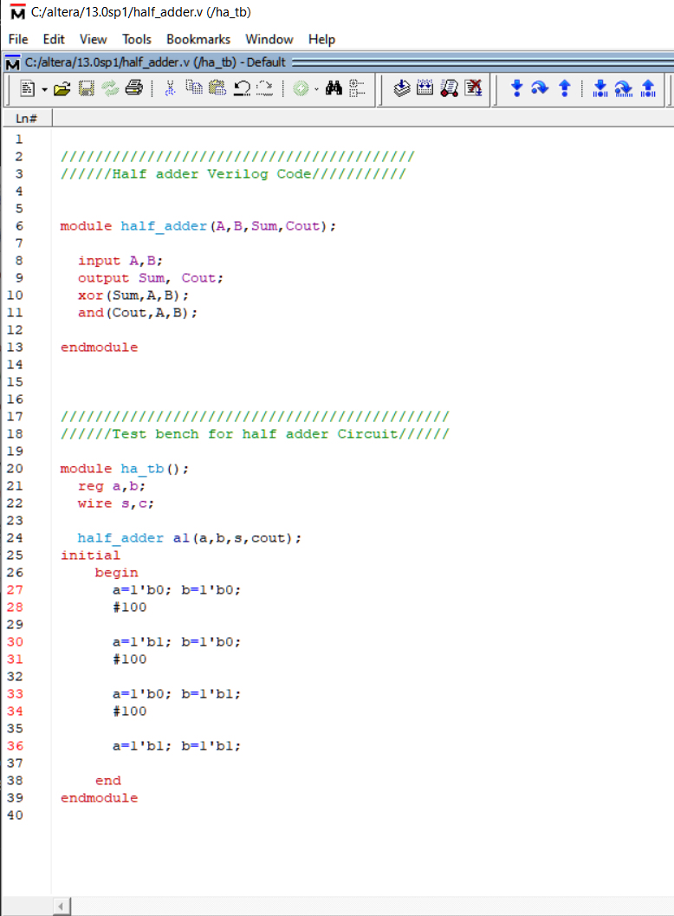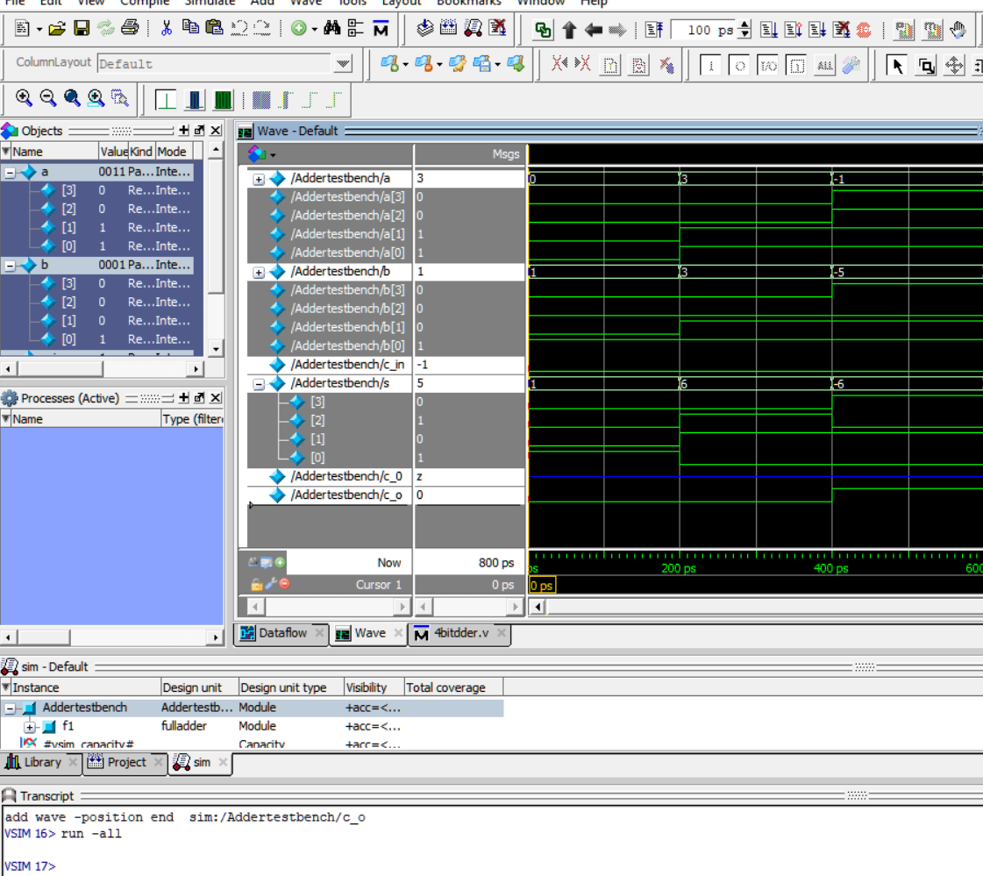

Verilog Simulation of a Full Adder: 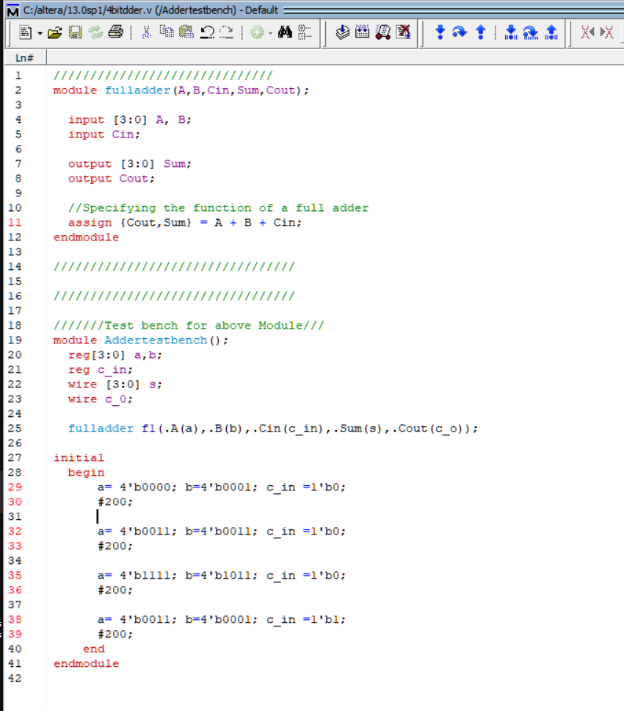 

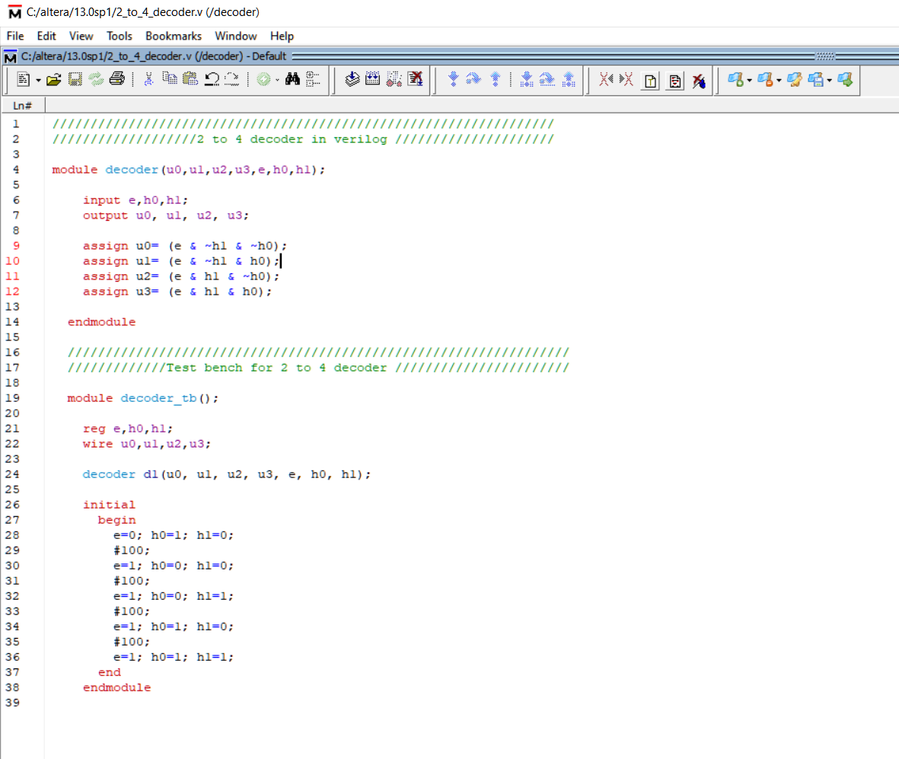Verilog Simulation of a 2 to 4 decoder:

